finwise
Personal Finance Advisor Bot
Your money, Clearer

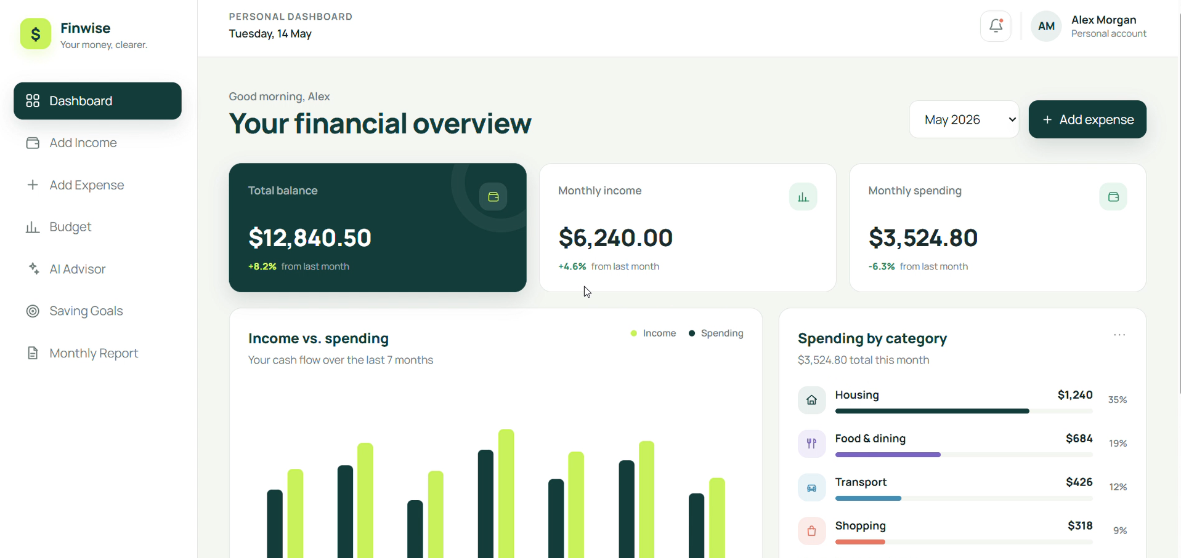
Project Documentation
A web-based personal finance management and AI-assisted budgeting platform

Introduction
Finwise is a personal finance management platform designed to help users understand and manage their money in a simple way. The application provides different financial tools through a single dashboard.
The main purpose of Finwise is to help users monitor their balance, income, spending, budget, savings, and financial progress. It also provides AI-powered financial guidance based on the user's financial activity.
The application has a clean and simple interface with different sections available from the left-side navigation menu.
The main sections shown in the application are:
- Dashboard
- Add Income
- Add Expense
- Budget
- AI Advisor
- Saving Goals
- Monthly Report
- Settings

2. Personal Dashboard
The Dashboard is the main screen of the Finwise application. It provides an overall view of the user's financial condition.
The dashboard contains important financial information such as:
- Total Balance
- Monthly Income
- Monthly Spending
- Income versus Spending
- Spending by Category
- Recent Transactions
- AI Financial Insights
The dashboard also allows the user to select a particular month and add a new expense.

3. Total Balance
The Total Balance card displays the user's current balance.
In the screen recording, the displayed total balance is:
$12,840.50
The dashboard also shows that the balance has increased by 8.2% from the previous month.
This section helps users quickly understand their available financial balance.
4. Monthly Income
The Monthly Income card shows the user's income for the selected period.
In the recording, the monthly income is:
$6,240.00
The dashboard indicates a 4.6% increase from the previous month.
This allows the user to understand the amount of income received during the month.
5. Monthly Spending
The Monthly Spending card displays the total amount spent during the selected month.
The recording shows:
$3,524.80
The spending is shown as 6.3% lower than the previous month.
This gives the user a quick indication of whether their spending is increasing or decreasing.
6. Income Versus Spending
Finwise provides an Income vs. Spending chart to show the user's cash flow over the last seven months.
The chart displays two different values:
- Income
- Spending
The months shown in the recording are:
November, December, January, February, March, April, and May.
The visual comparison makes it easier for the user to understand the relationship between money received and money spent.
If income is consistently higher than spending, the user can understand that more money is available for saving or other financial goals.
7. Spending by Category
Finwise also provides a Spending by Category section.
The recording shows total spending of:
$3,524.80
The main categories displayed are:
Housing
Amount: $1,240
Percentage: 35%
Housing is the largest displayed spending category.
Food & Dining
Amount: $684
Percentage: 19%
This category represents spending on food and dining activities.
Transport
Amount: $426
Percentage: 12%
This represents spending related to transportation.
Shopping
Amount: $318
Percentage: 9%
This represents the user's shopping expenses.
The category-based display helps users identify where most of their money is being spent.
8. Add Expense
The application includes an Add Expense option.
This feature allows the user to record a new expense in the system.
The expense can be entered with relevant information such as the expense description, amount, and category.
Recording expenses regularly helps the system maintain accurate spending information and update the dashboard.
9. Add Income
The application also provides an Add Income option.
This allows users to record their income and keep their financial information updated.
Income information can then be used by the dashboard to calculate and display financial summaries.
10. Recent Financial Activity
The Dashboard contains a section for Recent Transactions.
This section is designed to show the latest account activities so that users can quickly review their recent financial records.
The user can also select View All to access the complete transaction information.
11. Budget Section
The Budget section is used to help users plan their monthly spending and stay on track.
The screen recording shows a dedicated Budget page with two important areas:
- Monthly Cash Flow
- Budget Health
There is also an Add Expense button available on the page.
12. Monthly Cash Flow
The Monthly Cash Flow section displays income and spending across the last seven months.
The chart includes the following months:
- November
- December
- January
- February
- March
- April
- May
The chart allows the user to compare financial activity over time.
This makes it easier to identify changes in income and spending patterns.
13. Budget Health
The Budget Health section provides a score representing the user's current budget condition.
In the recording, the Budget Health score is:
82
The application describes this as a:
“Great score”
This gives the user a quick understanding of how well they are managing their spending.
14. Financial Planning
The Budget page is designed to help users plan their monthly spending.
By comparing income with spending, users can identify whether they are maintaining their planned financial limits.
The information provided by the Budget section can help users:
- Monitor spending
- Understand cash flow
- Maintain a healthy budget
- Identify changes in financial habits
- Plan future spending
15. AI Money Coach
The Budget screen also shows an AI Money Coach.
The AI Money Coach provides AI-powered guidance based on the user's spending.
The displayed message indicates that the system can review the user's spending and help create a plan to save additional money.
For example, the screen shows a suggestion to build a plan to save an extra $186 during the month.
This connects budget management with personalized financial guidance.
16. AI Advisor
The AI Advisor is one of the main features of Finwise.
The purpose of this section is to provide guidance based on the user's current financial situation.
The screen describes the feature as:
“Personal guidance based on your current financial picture.”
The AI Advisor can review the user's financial habits and provide suggestions related to spending and saving.
17. Financial Recommendation
In the recording, the AI Advisor provides a specific recommendation based on the user's financial activity.
The system states that the user is saving:
43.5% of their income this month.
It then recommends moving:
$500 to the emergency fund
and setting a:
$560 dining limit for June.
This shows how the system can convert financial information into specific recommendations.
18. AI Advisor Topics
The AI Advisor provides different topics that users can ask about.
The visible options include:
Review My Spending
This option helps users identify categories where they may be able to save money.
Plan My Budget
This option is intended to help users create a suitable budget based on their financial situation.
Reach a Goal
This option provides guidance for achieving a particular financial goal.
19. Finwise Coach
The application also contains a Finwise Coach interface.
The coach provides interactive financial guidance.
In the recording, the coach asks:
“I've reviewed your May spending. Want to build a plan to save an extra $186 this month?”
The user can select the suggested action or enter their own financial question.
This makes the application more interactive than a basic expense-tracking system.

20. Benefits of AI Guidance
The AI Advisor can help users understand their financial information more easily.
It can support users by:
- Reviewing spending patterns
- Suggesting savings opportunities
- Helping create spending limits
- Supporting financial goals
- Providing personalized guidance
The AI feature therefore acts as an additional financial support tool within the application.
21. Monthly Report
Finwise provides a Monthly Report section that summarizes the user's financial information for a particular month.
The recording shows a:
May 2026 Financial Report
The report displays three important values:
Income
$6,240
Expenses
$3,525
Saved
$2,715
These values provide a simple summary of the user's financial activity during the month.
22. Month at a Glance
The Monthly Report also provides a short summary of the user's financial performance.
The recording states that the user's savings rate reached:
43.5%
during the month.
It also indicates that the savings rate improved by 6.3% over April.
The report identifies Housing as the largest cost, while Food and Dining showed the best month-over-month improvement.
This gives the user a quick understanding of their financial performance.
23. AI Recommendations in Monthly Report
The Monthly Report includes AI-generated recommendations.
The recommendations shown in the recording are:
- Move $500 into the emergency fund this week.
- Set a $560 dining limit for June.
- Review unused subscriptions before renewal.
These recommendations are based on the financial information presented in the application.
24. Notification System
Finwise also provides notifications about financial progress.
The recording shows a notification stating:
“You're on track.”
It also indicates that dining spending is:
12% lower than this time last month.
This type of notification can help users stay aware of positive changes in their spending habits.
25. Overall Benefits
Finwise combines several financial management functions in one platform.
The main benefits shown in the recording are:
- Easy financial overview
- Income tracking
- Expense tracking
- Spending categorization
- Cash-flow visualization
- Budget monitoring
- Budget health score
- AI financial guidance
- Monthly financial reports
- Financial notifications
The dashboard makes financial information easier to understand through cards, charts, percentages, and summaries.
26. Conclusion
Finwise is designed to provide users with a simple and organized way to understand their personal finances.
The Dashboard gives an overall financial picture, while the Budget section helps users monitor cash flow and budget health.
The AI Advisor provides personalized financial suggestions, and the Monthly Report summarizes the user's financial performance.
The combination of financial tracking, visual information, budgeting, AI guidance, and reporting makes Finwise a useful personal finance management platform.
Overall, Finwise helps users understand their spending, manage their budget, monitor their savings, and make better financial decisions.

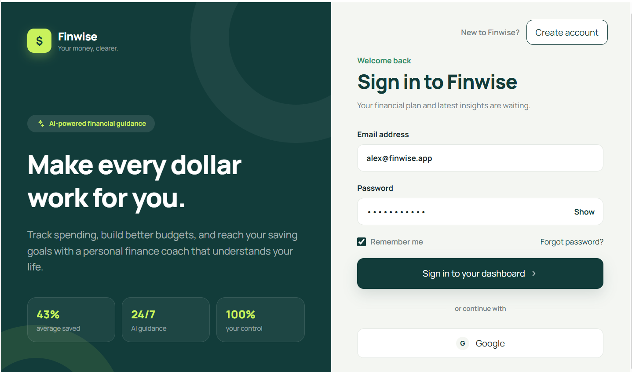

Figure 1: finwise login web page.

Figure 2: Responsive web dashboard showing balance, income, expenses and cash flow.

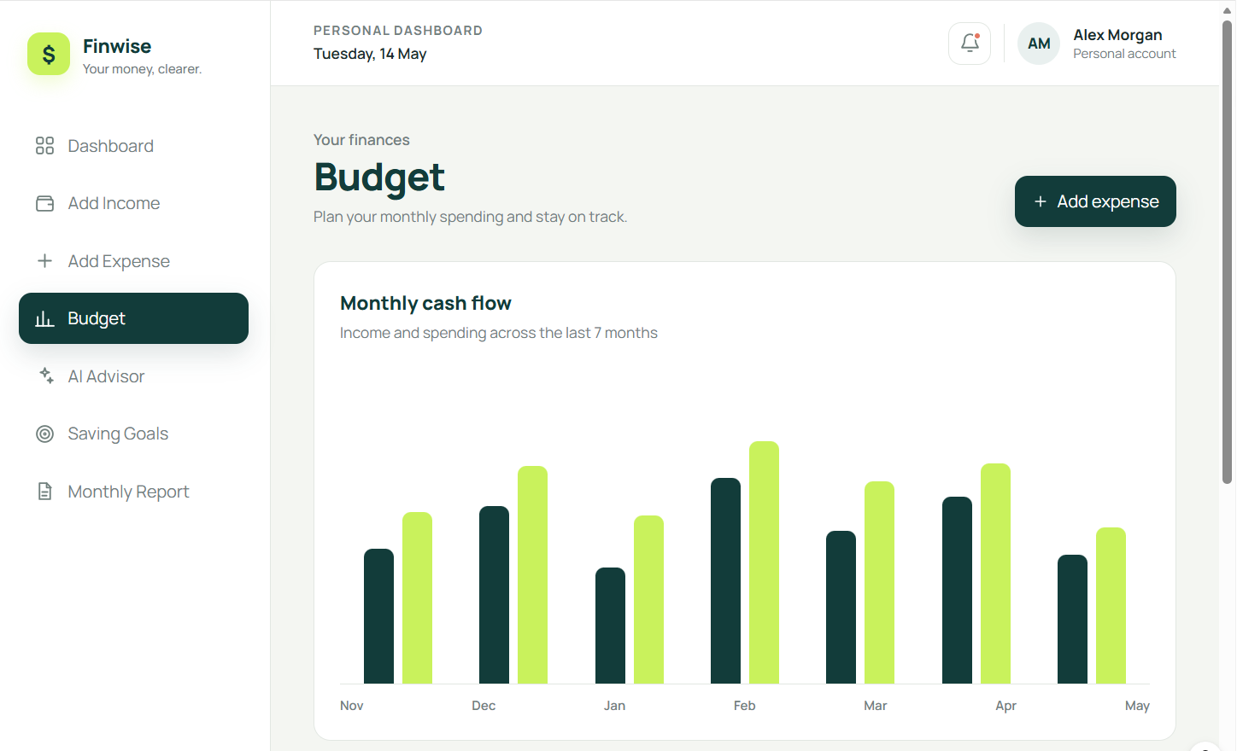
Figure 3: Mobile dashboard with budget usage and quick-access modules..

PRESENTED BY :-
Sakshi Gulabrao Jadhav

